Hexaflexagons
The following diagram illustrates how to fold one variety of Hexaflexagon from a straight strip of paper.
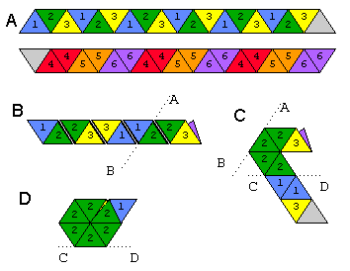
Cut a strip of paper and divide it into 19 equilateral triangles and number shown in (A) above. The blank triangle will be used to glue the contraption shut at the end. If this is your first model, you might want to fold all of the edges both ways a couple of times to make folding and flexing easier later.
Next, fold the strip so that the numbers on the back side face like numbers, that is, 4 on 4, 5 on 5, 6 on 6. The result is shown in (B) above. In effect, the strip has been folded into a flattened spiral.
Fold the strip back at line A-B, and then back at line C-D in Figure (C). On the final fold at C-D, bring the tail end of the strip up in front of the head so that the triangle numbered 3 faces the other triangle numbered 3. The result is shown in (D). Finally, fold the last triangle flap over and glue the two blank faces together. If you did it right, one face of the hexagon will have all triangles numbered 1 and the other face numbered 2.

How to Flex a Hexaflexagon
Start by pinching two triangles together along one of the edges. Push the outer corner of the opposite two triangles inward. Then, open up the opposite two triangles at the center to reveal an inner face of the Hexaflexagon. If they refuse to open, try pinching an adjacent pair of triangles. In the Hexahexaflexagon described here, if the model cannot open on one edge, it will surely open on an adjacent edge. If the model was badly constructed, it may be difficult to flex.
If you continue to flex the Hexaflexagon, it will eventually reveal all faces. For this model, faces 1, 2 and 3 will appear more often than 4, 5 and 6.

